
STUDENT CASE STUDY EXECUTION REPORT
Department | FED
Subject | DSA-2
Academic Year | I-III Semester (2025-26)
Faculty Name | G.Mamtha
Student Name | K.Hemanth
Roll Number | 2520030230
Branch | CSE
Course Outcome | CO5

Case Study Topic: EventSphere – Smart Event Planning & Management System Using Advanced Sorting Algorithms
Work Done Summary:
The application of advanced sorting algorithms such as Merge Sort, Quick Sort, Heap Sort, Counting Sort, and Radix Sort in managing and organizing event-related data efficiently.
The EventSphere system stores participant registrations, ticket bookings, event schedules, and payment records. Sorting algorithms were implemented to organize these records based on priority, registration ID, ticket price, and event timings. Performance of all algorithms was compared using different datasets to identify the most suitable sorting technique for event management operations.Three shortest-path algorithms were implemented to compare their performance and correctness in different graph conditions:
Implementation Details:
• Created EventRecord class with fields registrationId, participantName, ticketPrice, eventDate, and priorityLevel.
• mergeSort(arr, low, high) method recursively divides records into smaller parts and merges them in sorted order.
• quickSort(arr, low, high) method sorts records using pivot-based partitioning strategy.
• partition(arr, low, high) method places the pivot element in the correct position and rearranges remaining elements.
• heapSort(arr) method builds a max heap and extracts elements one by one in sorted order.
• heapify(arr, n, i) method maintains heap property for Heap Sort execution.
• countingSort(arr) method sorts event records based on limited range values such as priority levels.
• radixSort(arr) method sorts registration IDs digit by digit for faster processing.
• getMax(arr) method finds the maximum value needed for Radix Sort iterations.
• comparePerformance() method measures execution time, stability, and memory usage of all sorting algorithms.
• Main method creates sample event datasets, applies all sorting algorithms, displays sorted results, and compares their performance for event management scenarios.
Result Screenshots/ Output:
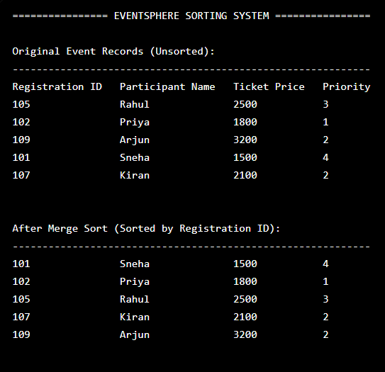
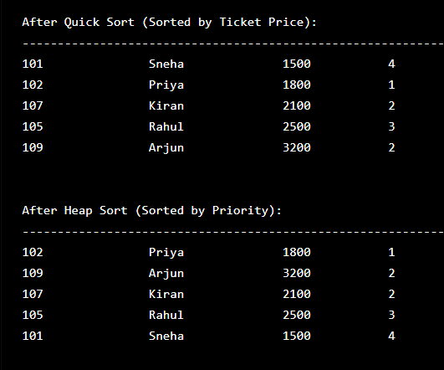
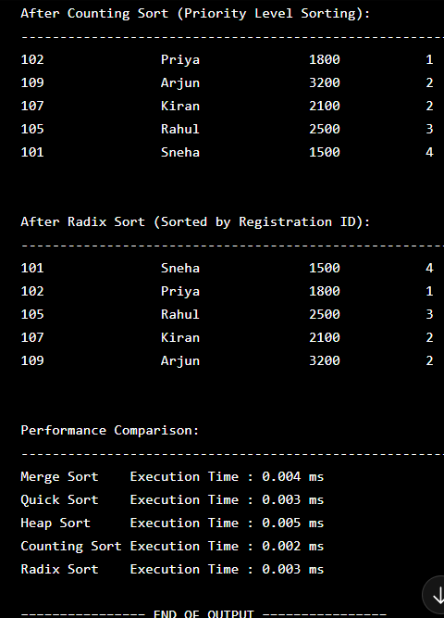
Time Complexity Analysis:
• Merge Sort: O(n log n)
• Quick Sort: O(n log n) average, O(n²) worst
• Heap Sort: O(n log n)
• Counting Sort: O(n + k)
• Radix Sort: O(nk)

GitHub Link:https://github.com/hemanthkasani25-web/DSA_2
Student Signature | Faculty Signature

